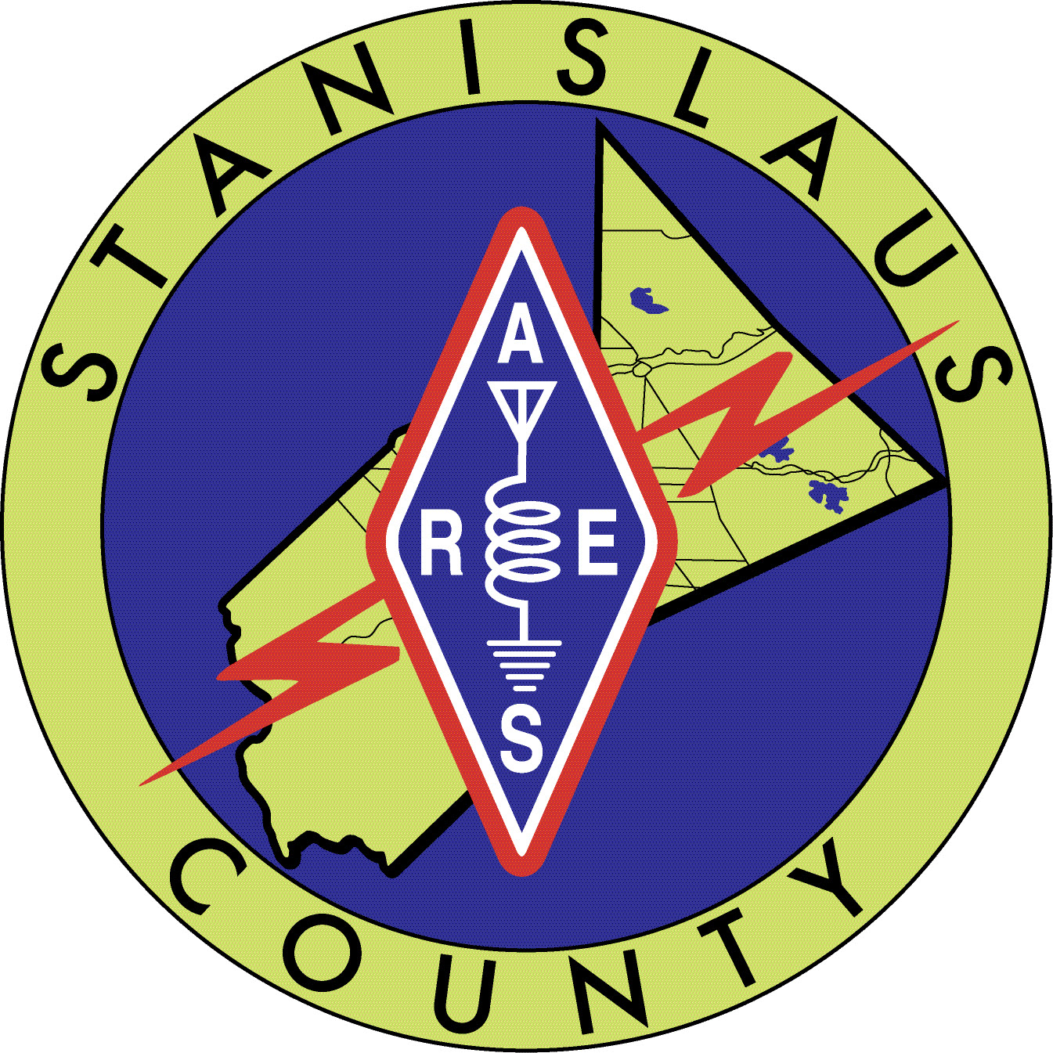

2023 ARES and SARA Club Meetings and Events Schedule as of
February 6, 2023
January

Saturday 7th ARES Meeting 10a-12p

Tuesday 17th SARA meeting 7p-8p

Saturday 28th and Sunday 29th Winter Field Day www.winterfieldday.com

February

Saturday 4th ARES Meeting 10a-12p

Tuesday 21st Sara Meeting 7p-8p

Saturday 25th Snelling Road Race Henderson Park Snelling, CA 7a-4p (depending on assignment) need 10 operators. This has been staffed. Wally KK6CNP is the Ham in charge of this event.

March

Saturday 4th ARES Meeting 10a-12p.

Tuesday 21st SARA Meeting 7p-8p

Saturday TBA??? Turlock Lake Road Race. Event appears cancelled. There is a new contact for this event, and he has not responded to a request for ride information as of 2-6-2023. The Turlock Lake Recreation area is still closed.

April

Saturday 1st ARES Meeting 10a-12pm.

Saturday 8th Copperopolis Road Race 7a-3p (depending on assignment) Hunt Road and Milton Road need 8-9 operators.

Tuesday 18th SARA Meeting 7p-8p

May

Saturday 13^{h} ARES Meeting 10a-12p

Tuesday 16th SARA Meeting 7p-8p

TBA Hospital Redundant Communications Drill. Need 6 ARES Operators

The Ride for MOM has been cancelled and retired. This event is no longer offered.

June

Saturday 3rd ARES Meeting 10a-12p

Sunday 4th Regalado Road Race 7a-12p Burchell Nursery 1200 California 120 (Highway 120/Wamble Road) Oakdale, CA 95361, need 8 operators

Tuesday 20th SARA Meeting 7p-8p

Saturday through Sunday (24^{th -} 25th) Field Day www.arrl.org/field-day

July

Saturday 8th ARES Meeting 10a-12p

Tuesday 18th SARA Meeting 7p-8p

August

Saturday 5th ARES Meeting 10a-12p

Saturday 5th Warnerville Time Trial 7a-12pm Willms Road East of Oakdale, near Knights Ferry need 5 operators.

Tuesday 15th SARA Meeting 7p-8p

September

Saturday 2nd ARES Meeting 10a-12p

Saturday September 9th Walk to End Alzheimers 8a-12p. 5 operators.

Tuesday 19th SARA Meeting 7p-8p

October

Saturday 14th ARES Meeting 10-12p

Friday-Sunday (13, 14, 15) Pacificon San Ramon Marriot

Tuesday 17th SARA Meeting 7p-8p

November

Saturday 4th ARES Meeting 10a-12p

Tuesday 21st SARA Meeting 7p-8p

December

Saturday 2nd ARES meeting 10a-12p

Tuesday 19th SARA meeting 7p-8p

